**4-(5-Chloro-[1,2,4]triazolo[4,3-a]pyrazin-3-yl)benzonitrile, OSM-S-219**

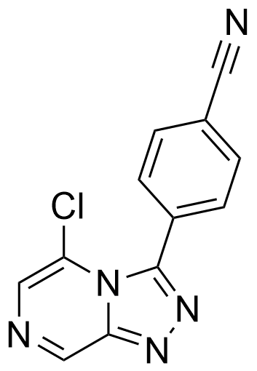

Representative Example: <http://malaria.ourexperiment.org/uri/4f0>

Prepared according to General Procedure **C** from: **OSM-S-303** (crude, 2.0 g, ~8.0 mmol); purified by automated flash chromatography over silica (Biotage Isolera, 50-100% EtOAc in hexanes) to give the title compound as an orange powder (1.14 g, 56%).

**m.p.** 226–227 ˚C;

**IR** νmax (film) /cm-1 3089, 2228, 1597;

**1H NMR** (200 MHz, DMSO-d*6*) δ: 9.53 (1H, s), 8.14 (1H, s), 8.08–7.93 (4H, m);

**13C NMR** (75 MHz, DMSO-d*6*) δ: 147.5, 146.6, 143.3, 132.2, 131.8, 131.4, 130.3, 121.7, 118.0, 114.9;

**m/z** (APCI+) 256 [M+H]+;

**HRMS** (ESI+) 256.03845 [M+H]+, C12H7N5Cl requires 256.03845.

***Strings:****ClC1=CN=CC2=NN=C(C3=CC=C(C#N)C=C3)N21*

*InChI=1S/C12H6ClN5/c13-10-6-15-7-11-16-17-12(18(10)11)9-3-1-8(5-14)2-4-9/h1-4,6-7H*

*IXZMOLDGRAEJRY-UHFFFAOYSA-N*